VITyarthi | Open Source Software

The Open Source Audit

A Capstone Project for OSS NGMC Course

Course: Open Source Software | Unit Coverage: 1 – 5 Max Marks: 100

Chosen Software: GIT

Student Name | Registration Number
Tanishka Arora | 24BAI10181
Slot | Date of Submission
B22 | 30-03-2026

Introduction

Most of the software we use today is not built by a single company, but by a community of developers working together. This is what open-source software is all about. It allows people to share their work, improve it, and use it freely.

In this project, I have chosen Git as my open-source software. Git is a version control system that helps developers track changes in their code and collaborate with others. It is widely used in almost every software development project today.

Git was originally created to solve real problems faced during Linux development. Over time, it became very popular because of its speed and flexibility. Since it is open source, developers around the world contribute to improving it.

In this report, I will study Git from different perspectives such as its origin, license, working in Linux, and its role in the open-source ecosystem. I will also compare it with proprietary software.

Along with the report, I have created five shell scripts to demonstrate basic Linux commands and automation. These scripts helped me understand how open-source tools work in practice.

Choosing Your Software

Your choice | Write your chosen software here before submission: Git

Part A — Origin and Philosophy (Units 1 & 2)

A1. Origin Story

Git was created in 2005 by Linus Torvalds, who is also known for creating the Linux kernel. Before Git, the Linux project was using a proprietary tool called BitKeeper to manage code changes.

However, due to some licensing issues, the Linux community lost access to BitKeeper. This created a serious problem because thousands of developers were working on the Linux kernel, and they needed a reliable system to manage changes.

At that time, the available version control systems were either too slow or not suitable for distributed development. So Linus Torvalds decided to build his own system.

He developed Git with the goal of making it fast, efficient, and capable of handling large projects. One important feature of Git is that it is distributed, meaning every developer has a full copy of the project.

Instead of keeping Git private, Linus released it as open source under the GPL license. This allowed developers all over the world to use and improve it. Because of this, Git quickly became the most popular version control system.

A2. License: what it actually says

Git is licensed under the GNU General Public License version 2 (GPL v2). This license is designed to give users complete freedom over the software.

There are four main freedoms in open-source software:
- The freedom to use the software for any purpose
- The freedom to study how it works and modify it
- The freedom to share copies with others
- The freedom to distribute modified versions

Git follows all these freedoms. This means anyone can use Git, modify it, and even share their modified versions.

One important feature of the GPL license is that if someone modifies the software and distributes it, they must also share the source code. This ensures that the software always remains open.

This is different from licenses like MIT, where companies can modify the software and keep their changes private. In my opinion, GPL is better for projects like Git because it protects the open-source nature.

Git is not just free to use, but also gives full control to the user, which is the real meaning of open source.

A3. The ethics of open source

Open-source software raises an interesting question: should all software be open source?

On one hand, open source promotes transparency and sharing of knowledge. Anyone can check the code, which makes it more secure. It also helps students and developers learn from real projects. Not all companies can afford to make their software open source. Some projects require a lot of investment, and companies need profit to sustain themselves.

Companies like Google and Microsoft also use open-source software like Linux. Some people feel this is unfair, but these companies also contribute back to the community.

The idea of "standing on the shoulders of giants" is very important here. Developers today do not start from scratch. They build on existing tools like Git, Linux, and Python.

In my opinion, open source supports innovation rather than limiting it. It saves time and allows developers to focus on new ideas instead of reinventing things.

Part B — Linux Footprint (Unit 2)

Git works very smoothly in a Linux environment and is often pre-installed in many distributions.

Git can be installed using commands like:
sudo apt install git

Once installed, Git is usually located in /usr/bin/git. Configuration files are stored in the user’s home directory, such as ~/.gitconfig.

Git runs under the current user and does not require root access. This makes it safe and easy to use. Unlike some software, Git does not run as a background service. It is used through commands in the terminal.

Updates for Git are provided through package managers, and improvements are made regularly by the open-source community.

Part C — The FOSS Ecosystem (Units 3 & 4)

Git plays a very important role in the open-source ecosystem.

It is used by platforms like GitHub, GitLab, and Bitbucket, which allow developers to collaborate on projects from anywhere in the world.
Git does not work alone. It depends on basic system tools, but it also enables many other applications and services.

There is a large community of developers who contribute to Git. They fix bugs, add features, and improve performance. Git is also closely connected to the web, as most code hosting platforms are web-based.

Part D — Open Source vs Proprietary (Critical Analysis)

Dimension | Open Source | Proprietary Alternative
Cost | Git is completely free to use, download, and modify. | Proprietary tools often require paid licenses, especially for enterprise usage.
Security (who can audit the code?) | The source code is publicly available, so anyone can review it and find vulnerabilities. | The source code is closed, so only the company can check and fix security issues.
Support and reliability | Supported by a large global community with extensive documentation, forums, and frequent updates. | Provides official customer support, but depends on subscription and company response time.
Freedom to modify | Users can freely modify Git and even create their own versions according to their needs. | Users cannot modify the software and must follow company-imposed restrictions.
Community vs corporate control | Developed and maintained by a global open-source community where contributions are shared. | Controlled by a company, where decisions are driven by business goals.
Your overall verdict | Git is flexible, free, and widely used, making it ideal for developers and collaborative projects. | Proprietary tools may offer structured support but lack flexibility and freedom.

Conclusion
From my perspective, Git is a better choice for most developers because it is free, flexible, and widely supported. It allows full control over the code and encourages collaboration. While proprietary tools may provide dedicated support, they are often costly and restrictive in terms of usage and customization.

Shell Script Tasks

Script 1 — System Identity Report (Unit 1 & 2)

#!/bin/bash
# Script 1: System Identity Report
# Author: Tanishka Arora

STUDENT_NAME="Tanishka Arora"
SOFTWARE_CHOICE="Git"

KERNEL=$(uname -r)
USER_NAME=$(whoami)
DATE=$(date)

# Handle uptime safely
if command -v uptime >/dev/null 2>&1; then
UPTIME=$(uptime -p)
else
UPTIME="Not available (Git Bash)"
fi

# Handle distro safely
if [ -f /etc/os-release ]; then
DISTRO=$(grep PRETTY_NAME /etc/os-release | cut -d= -f2 | tr -d '"')
else
DISTRO="Not available (Git Bash)"
fi

echo "================================"
echo " Open Source Audit — $STUDENT_NAME"
echo "================================"
echo "Software Chosen : $SOFTWARE_CHOICE"
echo "Kernel : $KERNEL"
echo "User : $USER_NAME"
echo "Distro : $DISTRO"
echo "Uptime : $UPTIME"
echo "Date & Time : $DATE"
echo "License : Linux is mostly under GPL License"
echo "================================"
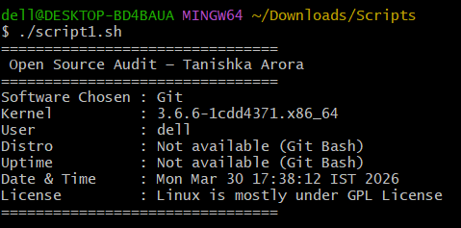

Script 2 — FOSS Package Inspector (Unit 2)

#!/bin/bash
# Script 2: FOSS Package Inspector
# Author: Tanishka Arora

PACKAGE="git"

echo "Checking package: $PACKAGE"
echo "---------------------------"

if command -v $PACKAGE >/dev/null 2>&1; then
echo "$PACKAGE is installed."
VERSION=$($PACKAGE --version)
echo "Version: $VERSION"
else
echo "$PACKAGE is NOT installed."
fi

# Case statement
case $PACKAGE in
git) echo "Git: version control system enabling open collaboration" ;;
vlc) echo "VLC: open-source media player" ;;
firefox) echo "Firefox: open web browser" ;;
apache2) echo "Apache: powerful web server" ;;
*) echo "Unknown software" ;;
esac

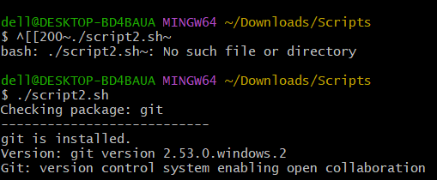

Script 3 — Disk and Permission Auditor (Unit 2)

#!/bin/bash
# Script 3: Disk and Permission Auditor

DIRS=("/etc" "/var/log" "/home" "/usr/bin" "/tmp")

echo "Note: Some directories may not exist in Git Bash environment"
echo "Directory Audit Report"
echo "----------------------"

for DIR in "${DIRS[@]}"; do
if [ -d "$DIR" ]; then
PERMS=$(ls -ld $DIR 2>/dev/null | awk '{print $1, $3, $4}')
SIZE=$(du -sh $DIR 2>/dev/null | cut -f1)
echo "$DIR => Permissions: $PERMS | Size: $SIZE"
else
echo "$DIR does not exist"
fi
done

# Check Git config directory
if [ -d "$HOME/.git" ]; then
echo "Git config found:"
ls -ld "$HOME/.git"
else
echo "No Git config directory found"
fi

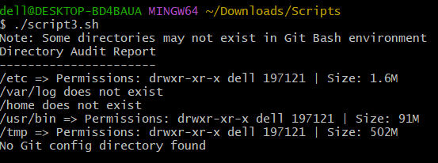

Script 4 — Log File Analyzer (Units 2 & 5)

#!/bin/bash
# Script 4: Log File Analyzer

LOGFILE=$1
KEYWORD=${2:-"error"}
COUNT=0

if [ ! -f "$LOGFILE" ]; then
echo "Error: File not found!"
exit 1
fi

while IFS= read -r LINE
do
if echo "$LINE" | grep -iq "$KEYWORD"; then
COUNT=$((COUNT + 1))
fi
done < "$LOGFILE"

echo "Keyword '$KEYWORD' found $COUNT times in $LOGFILE"

echo "Last 5 matches:"
grep -i "$KEYWORD" "$LOGFILE" | tail -5

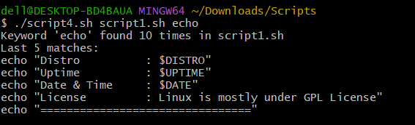

Script 5 — The Open Source Manifesto Generator (Unit 5)
#!/bin/bash
# Script 5: Open Source Manifesto Generator

echo "Answer 3 questions:"
echo ""

read -p "1. Tool you use daily: " TOOL
read -p "2. Freedom means: " FREEDOM
read -p "3. What will you build: " BUILD

DATE=$(date '+%d %B %Y')
OUTPUT="manifesto.txt"

echo "----- Open Source Manifesto -----" > $OUTPUT
echo "Date: $DATE" >> $OUTPUT
echo "" >> $OUTPUT
echo "I believe open source stands for $FREEDOM." >> $OUTPUT
echo "Tools like $TOOL empower developers worldwide." >> $OUTPUT
echo "I aim to build $BUILD and share it freely with others." >> $OUTPUT

echo ""
echo "Manifesto saved in $OUTPUT"
cat $OUTPUT

